Test Case: tc001_SPX_Dev5_Consulta_Administracion_Accesos
Step 1 - Enter username and password and click to button Enter : Credentials Entered
Image file-name: QC_Testing-tc001_SPX_Dev5_Consulta_Administracion_Accesos-dic. 26 2025, 03 25 19 p. m.

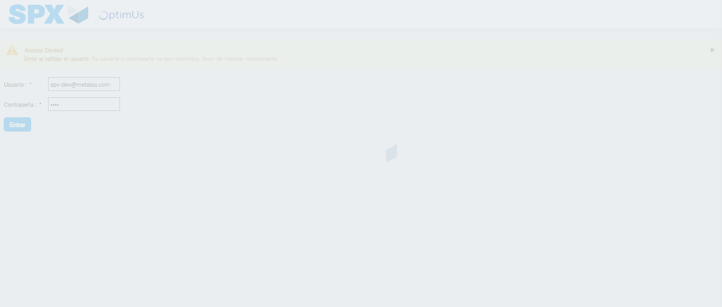Image file-name: QC_Testing-tc001_SPX_Dev5_Consulta_Administracion_Accesos-dic. 26 2025, 03 25 20 p. m.

Step 2 - Select to UEN and Access to Administraci�n de Accesos: UEN Correctly selected and Correct access
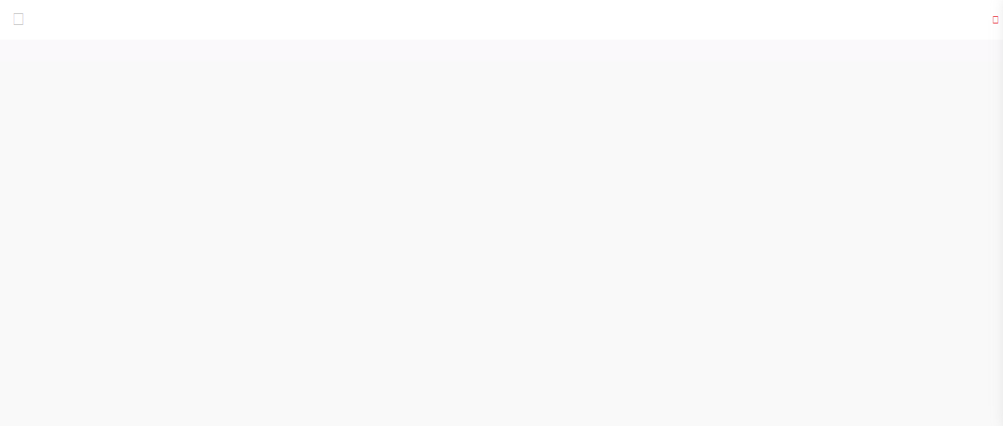Image file-name: QC_Testing-tc001_SPX_Dev5_Consulta_Administracion_Accesos-dic. 26 2025, 03 25 29 p. m.

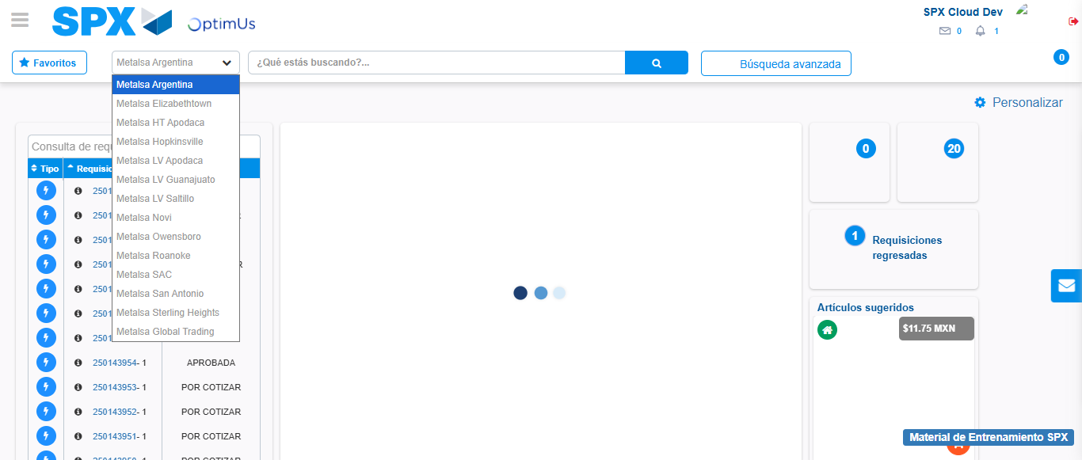Image file-name: QC_Testing-tc001_SPX_Dev5_Consulta_Administracion_Accesos-dic. 26 2025, 03 25 31 p. m.

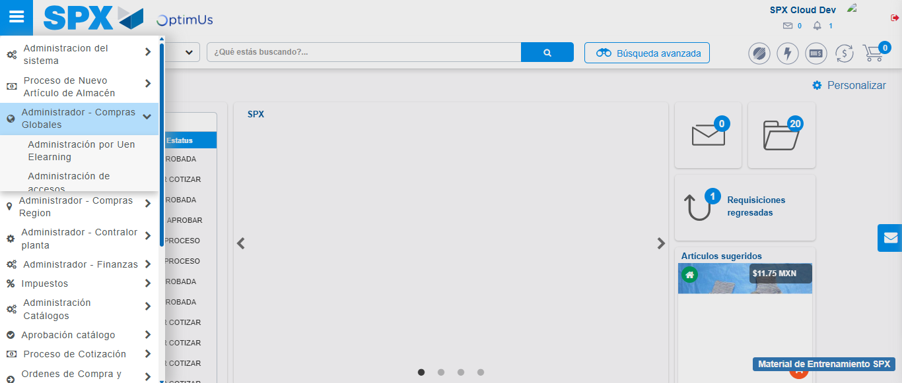Image file-name: QC_Testing-tc001_SPX_Dev5_Consulta_Administracion_Accesos-dic. 26 2025, 03 25 32 p. m.

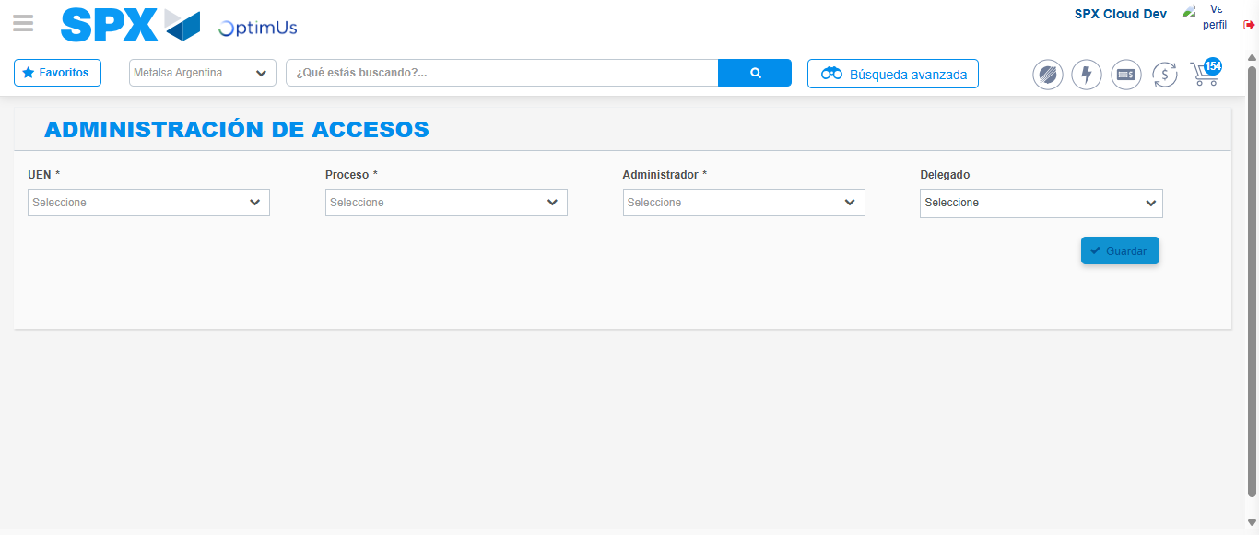Image file-name: QC_Testing-tc001_SPX_Dev5_Consulta_Administracion_Accesos-dic. 26 2025, 03 25 40 p. m.

Step 3 - Review information on Aprobaci�n Catalogos: Correct Data
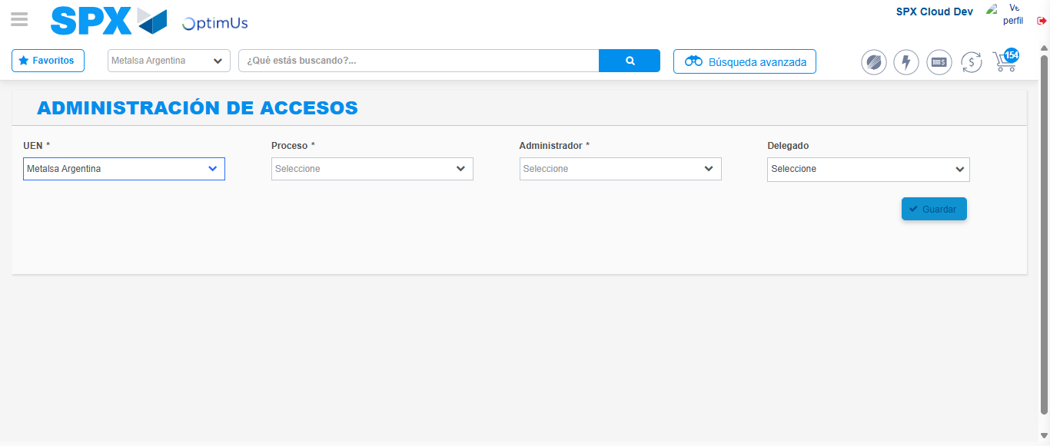Image file-name: QC_Testing-tc001_SPX_Dev5_Consulta_Administracion_Accesos-dic. 26 2025, 03 25 41 p. m.

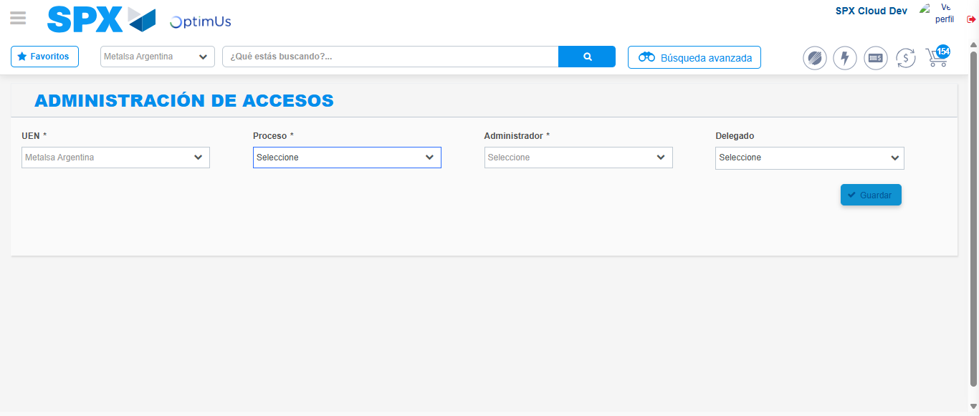Image file-name: QC_Testing-tc001_SPX_Dev5_Consulta_Administracion_Accesos-dic. 26 2025, 03 25 42 p. m.

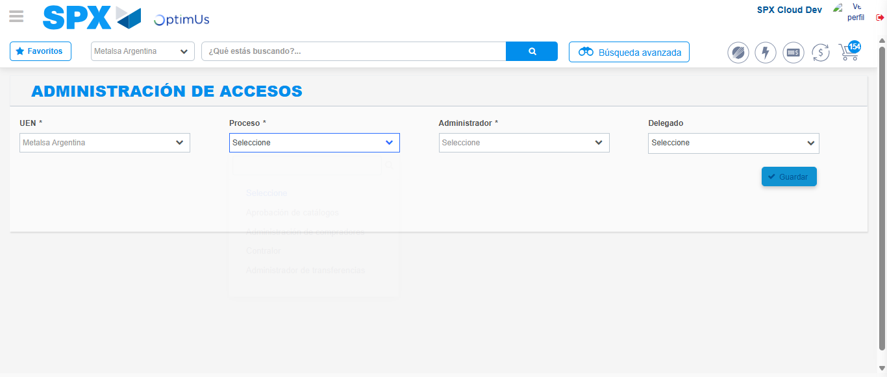Image file-name: QC_Testing-tc001_SPX_Dev5_Consulta_Administracion_Accesos-dic. 26 2025, 03 25 57 p. m.

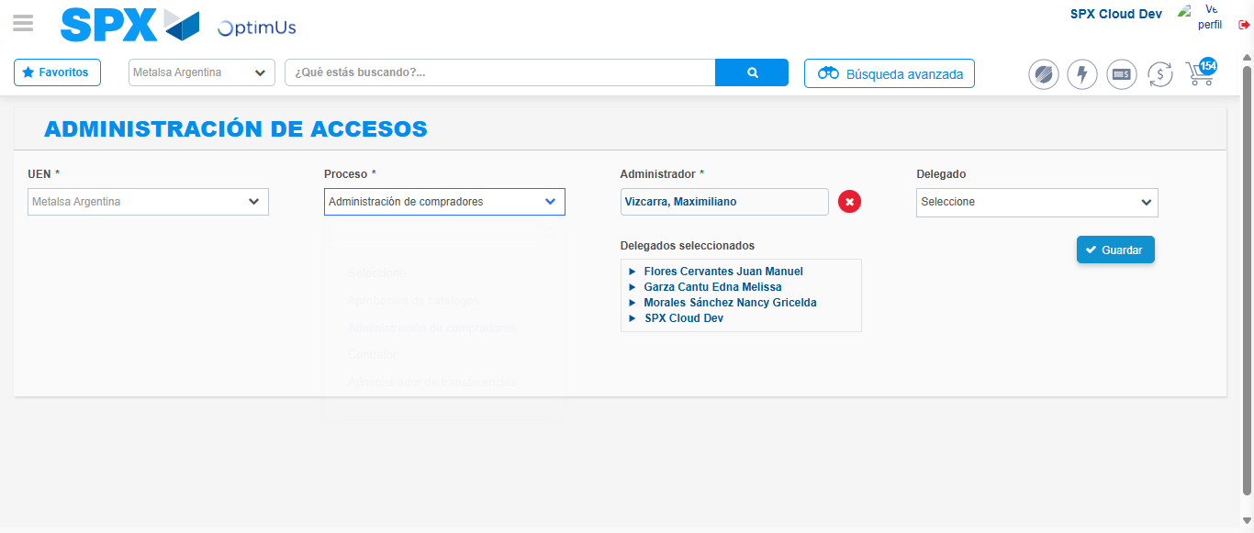Image file-name: QC_Testing-tc001_SPX_Dev5_Consulta_Administracion_Accesos-dic. 26 2025, 03 25 58 p. m.

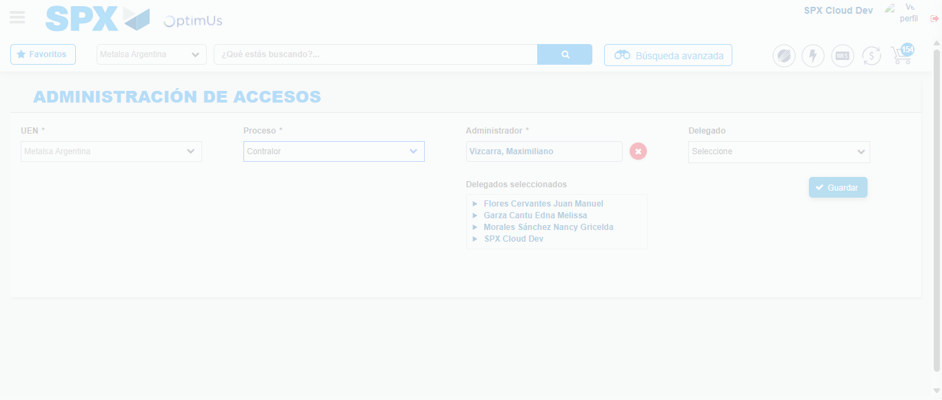Image file-name: QC_Testing-tc001_SPX_Dev5_Consulta_Administracion_Accesos-dic. 26 2025, 03 25 59 p. m.

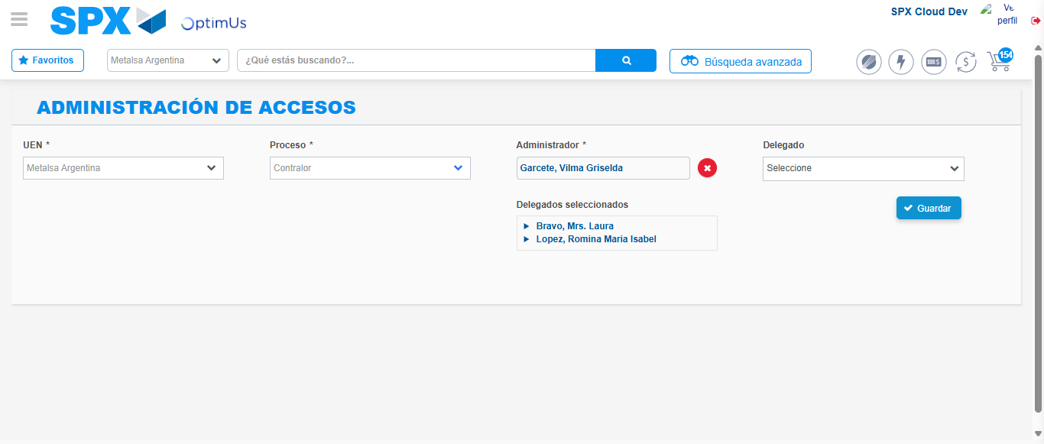Image file-name: QC_Testing-tc001_SPX_Dev5_Consulta_Administracion_Accesos-dic. 26 2025, 03 26 14 p. m.

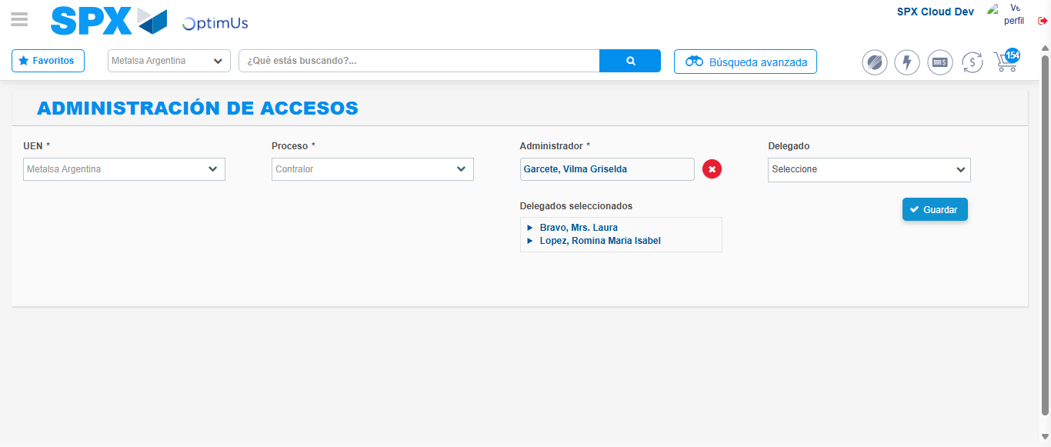Image file-name: QC_Testing-tc001_SPX_Dev5_Consulta_Administracion_Accesos-dic. 26 2025, 03 26 15 p. m.

